|  |  |
| --- | --- |
| **Course: WEB TECHNOLOGIES**  **Worksheet #3**  **NAME – MOHIT RANA**  **UID – 20BCS1156** | |
|
|  |  |
| **Sr. No.** | **Implementation using various JavaScript Programs in Notepad** |
| **1** | Create a webpage which should have JavaScript program to set the background color of a paragraph. |
| **2** | Declare variable and assign value, define function that returns text, declare a function to return characters of a string in Upper/lowercase and a function to get first element of an array. |
| **3** | Link a JS file into a HTML file, put an alert, and a program that tells date and time. |
| **4** | Write a JavaScript program where the program takes a random integer between 1 to 10, the user is then prompted to input a guess number. If the user input matches with guess number, the program will display a message "Good Work" otherwise display a message "Not matched".. |
| **6** | Create a HTML form and make a connection of database with it. |

**1.Create a webpage which should have JavaScript program to set the background color of a paragraph.**

**CODE –**

<!DOCTYPE *html*>

<html>

<head>

    <title>Answer 1</title>

</head>

<center>

<body bgcolor="lightyellow" *style*="font-size: 30px;font-family: serif;">

<script *type*="text/javascript">

  function myfun(){

    document.getElementById("demo").style.fontsize="50px";

    document.getElementById("demo").style.color="red";

    document.getElementById("demo").style.backgroundColor="black";

  }

    </script>

    <button *type*="button" *onclick*="myfun()">Click to change</button>

    <p *id*="demo">You can see the background color has been canged</p>

</center>

</body>

</html>

**OUTPUT –**

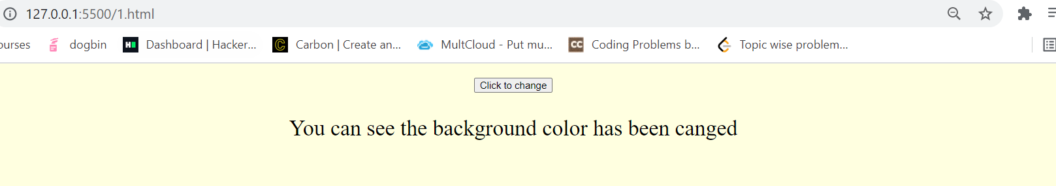

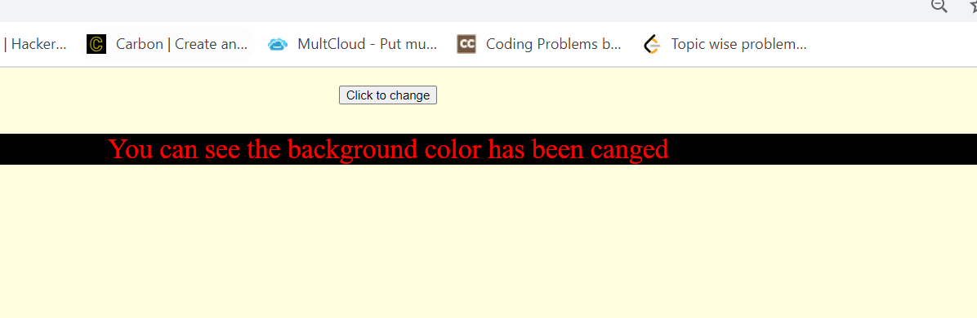

**2. Declare variable and assign value, define function that returns text, declare a function to return characters of a string in Upper/lowercase and a function to get first element of an array.**

**CODE –**

<html>

  <head>

    <title>Variables!!!</title>

  </head>

  <body>

    <center>

      <h2 *style*="color: blueviolet" *;*>Declare variable and assign value</h2>

      <h1 *style*="color: blue">

        <script *type*="text/javascript">

          var one = 22;

          document.write(one);

        </script>

      </h1>

    </center>

  </body>

</html>

<!DOCTYPE *html*>

<html>

  <body>

    <p *id*="demo"></p>

    <center>

      <h1>

        <script>

          function myFunction() {

            return "Hello Mohit";

          }

          document.getElementById("demo").innerHTML = myFunction();

        </script>

      </h1>

    </center>

  </body>

</html>

<!DOCTYPE *html*>

<html>

  <head>

    <meta *charset*="utf-8" />

    <title></title>

  </head>

  <body>

    <script *type*="text/javascript">

      var ary = ["first", "second", "third", "fourth", "fifth"];

      alert(ary[0]);

    </script>

  </body>

</html>

**OUTPUT –**

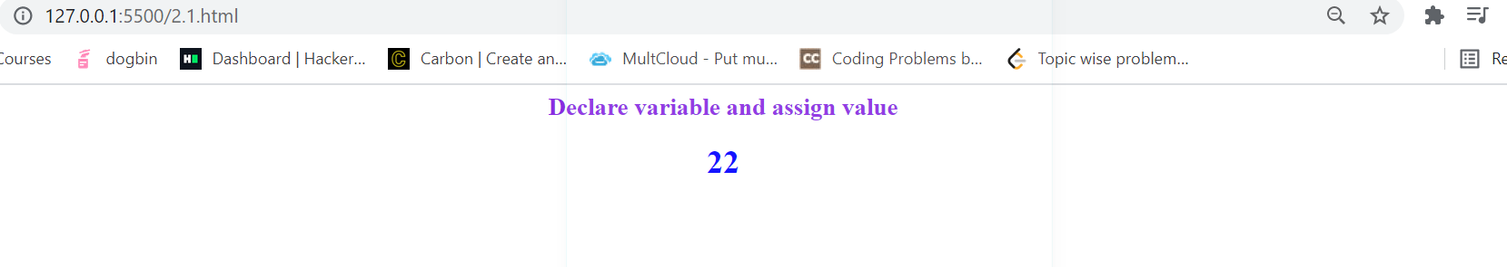

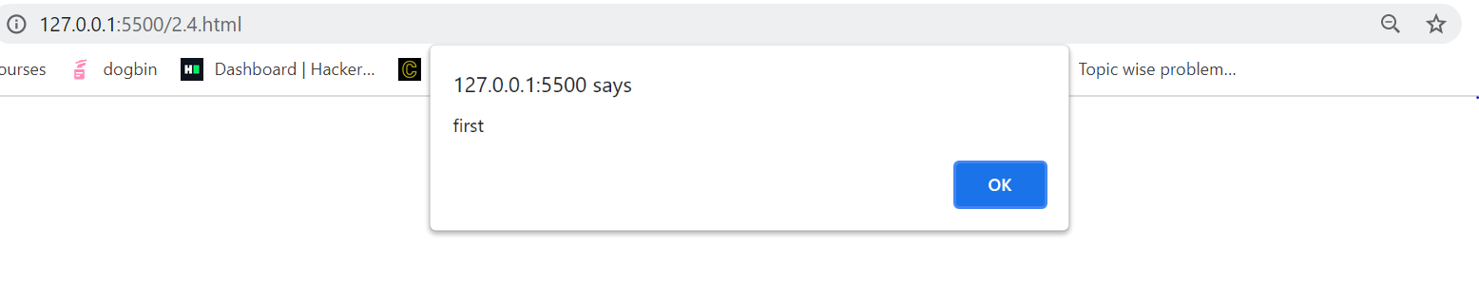

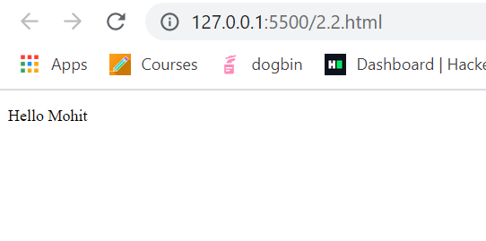

**3. Link a JS file into a HTML file, put an alert, and a program that tells date and time.**

**CODE –**

<!DOCTYPE *html*>

<html>

  <head>

    <meta *charset*="utf-8" />

    <title>Display date</title>

    <script>

      alert("hi");

      function displayDate() {

        document.getElementById("showDate").innerHTML = Date();

      }

    </script>

  </head>

  <body>

    <button *type*="button" *onclick*="displayDate()">Show Date</button>

    <p *id*="showDate"></p>

  </body>

</html>

OUTPUT –

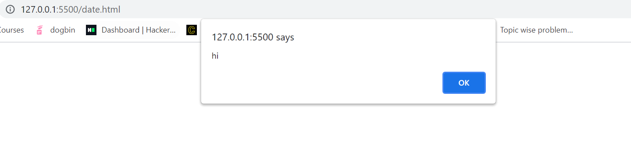

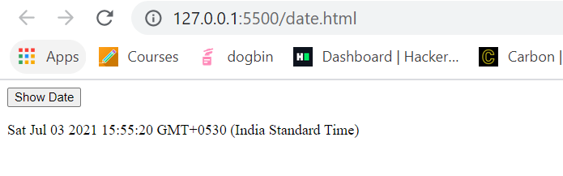

**4. Write a JavaScript program where the program takes a random integer between 1 to 10, the user is then prompted to input a guess number. If the user input matches with guess number, the program will display a message "Good Work" otherwise display a message "Not matched"..**

**Code –**

<!DOCTYPE *html*>

<html>

<head>

    <meta *charset*="utf-8">

    <title>Guess a number</title>

</head>

<body>

    <script >

        const num = Math.ceil(Math.random() * 10);

        console.log(num);

        const gnum = prompt('Guess the number between 1 and 10 inclusive');

            if (gnum == num)

                document.write('matched')

            else

                document.write('not matched')

    </script>

</body>

</html>

OUTPUT –

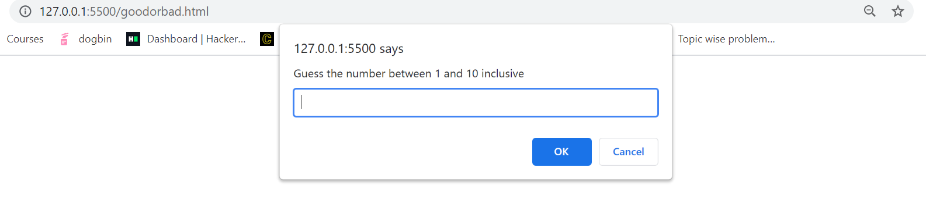

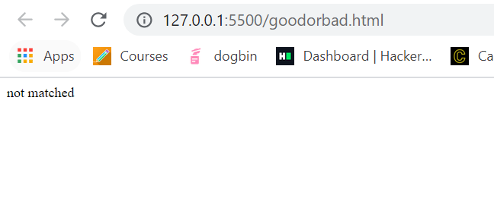

**5. Create a HTML form and make a connection of database with it.**

**Code –**

**PhpMyAdmin**

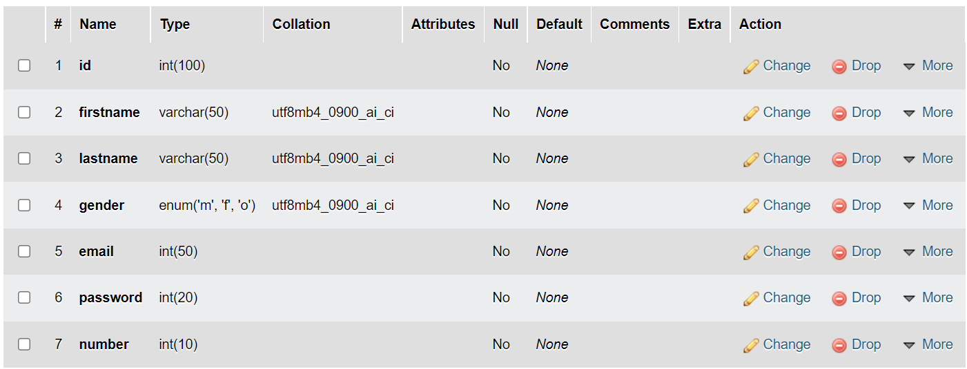

**PHP**

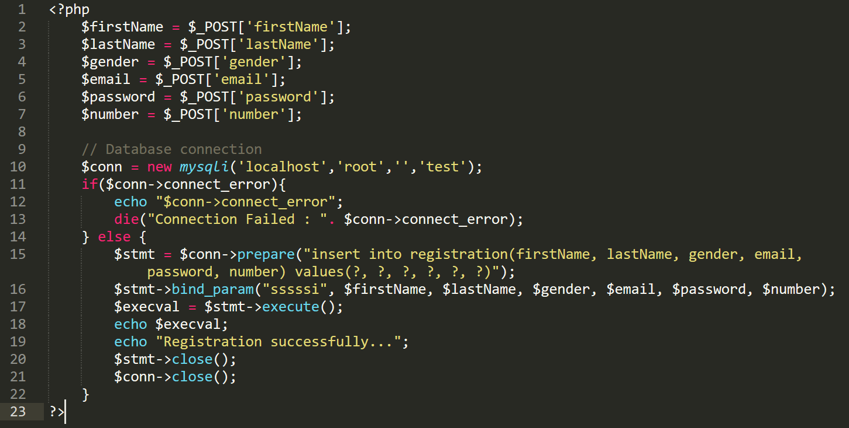

**Html**

<!DOCTYPE *html*>

<html>

  <head>

    <title>Registration Page</title>

    <link *rel*="stylesheet" *type*="text/css" *href*="css/bootstrap.css" />

  </head>

  <body>

    <div *class*="container">

      <div *class*="row col-md-6 col-md-offset-3">

        <div *class*="panel panel-primary">

          <div *class*="panel-heading text-center">

            <h1>Registration Form</h1>

          </div>

          <div *class*="panel-body">

            <form *action*="connect.php" *method*="post">

              <div *class*="form-group">

                <label *for*="firstName">First Name</label>

                <input

*type*="text"

*class*="form-control"

*id*="firstName"

*name*="firstName"

                />

              </div>

              <div *class*="form-group">

                <label *for*="lastName">Last Name</label>

                <input

*type*="text"

*class*="form-control"

*id*="lastName"

*name*="lastName"

                />

              </div>

              <div *class*="form-group">

                <label *for*="gender">Gender</label>

                <div>

                  <label *for*="male" *class*="radio-inline"

                    ><input

*type*="radio"

*name*="gender"

*value*="m"

*id*="male"

                    />Male</label

                  >

                  <label *for*="female" *class*="radio-inline"

                    ><input

*type*="radio"

*name*="gender"

*value*="f"

*id*="female"

                    />Female</label

                  >

                  <label *for*="others" *class*="radio-inline"

                    ><input

*type*="radio"

*name*="gender"

*value*="o"

*id*="others"

                    />Others</label

                  >

                </div>

              </div>

              <div *class*="form-group">

                <label *for*="email">Email</label>

                <input

*type*="text"

*class*="form-control"

*id*="email"

*name*="email"

                />

              </div>

              <div *class*="form-group">

                <label *for*="password">Password</label>

                <input

*type*="password"

*class*="form-control"

*id*="password"

*name*="password"

                />

              </div>

              <div *class*="form-group">

                <label *for*="number">Phone Number</label>

                <input

*type*="number"

*class*="form-control"

*id*="number"

*name*="number"

                />

              </div>

              <input *type*="submit" *class*="btn btn-primary" />

            </form>

          </div>

          <div *class*="panel-footer text-right">

            <small>&copy; Technical Babaji</small>

          </div>

        </div>

      </div>

    </div>

    <div *class*="toast" *role*="alert" *aria-live*="assertive" *aria-atomic*="true">

  <div *class*="toast-header">

    <img *src*="..." *class*="rounded mr-2" *alt*="...">

    <strong *class*="mr-auto">Bootstrap</strong>

    <small>11 mins ago</small>

    <button *type*="button" *class*="ml-2 mb-1 close" *data-dismiss*="toast" *aria-label*="Close">

      <span *aria-hidden*="true">&times;</span>

    </button>

  </div>

  <div *class*="toast-body">

    Hello, world! This is a toast message.

  </div>

</div>

  </body>

</html>

**OUTPUT –**

